Identifying Positive and Negative News About Stocks from Finance Data Company Using Sentiment Analysis with Visualization

Farah Wira Syahni  
School of Computer Science  
Bina Nusantara UniversityJakarta, Indonesia  
farah.syahni@binus.ac.id

*Abstract*—

*Sentiment analysis is a technique in natural language processing used to identify, analyze, and evaluate sentiments, opinions, or emotions contained in text or conversations. The goal of sentiment analysis is to classify text into different sentiment categories, such as positive, negative, or neutral.*

*In this paper, we propose an approach that uses sentiment analysis with visualization to identify positive and negative news about stocks. Sentiment analysis is a technique used to express and evaluate opinions and emotions from text related to a topic. We focus on news related to stocks in this context. Our proposed approach integrates the sentiment analysis process with data visualization to visualize the results in an intuitive and informative way. We collect stock-related news data from various online sources and apply sentiment analysis algorithms to classify the news into positive or negative. Furthermore, we use suitable visualization techniques to graphically present the sentiment analysis results to users. By utilizing sentiment analysis and visualization, users can easily understand the general market sentiment towards a stock and make more informed investment decisions.*

Keywords—sentiment analysis, data visualization, stock news, opinion, emotion, investmen.

# **Introduction**

The stock market is a complex and dynamic environment where investors make decisions based on various factors, including news and market sentiment. News articles and reports play an important role in shaping investors' perceptions and influencing their investment decisions. However, manually analyzing large volumes of news data can be a time-consuming and challenging task. Therefore, automated techniques that can identify and analyze sentiment in stock-related news articles are of great interest to investors and financial professionals. Sentiment analysis, also known as opinion mining, is a field of natural language processing that focuses on extracting and understanding subjective information, such as opinions, emotions, and attitudes from text data. By utilizing sentiment analysis techniques, investors can gain valuable insights into the overall market sentiment regarding specific stocks. However, understanding sentiment alone is not always enough; visualizing sentiment analysis results can provide a more intuitive and comprehensive understanding of sentiment patterns and trends. In this paper, we propose an approach that combines sentiment analysis with visualization techniques to identify positive and negative news about stocks. Our goal is to develop a system that can automatically process large volumes of news articles, classify them into positive or negative sentiment categories, and present the sentiment analysis results in an easy-to-interpret visual format.

To collect data in this project, I used several techniques. These techniques are using the "urllib" library to make HTTP requests and access finviz. com web page containing stock news, the "BeautifulSoup" library for scraping and extracting information from web pages, the "NLTK" library and its module "SentimentIntensityAnalyzer" to analyze sentiment in stock news text, calculate sentiment scores based on news text using the polarity_scores" method of the “SentimentIntensityAnalyzer” object, then there is the "matplotlib" library to visualize the results of sentiment analysis by creating graphs that show the distribution of positive and negative sentiments in stock news.

This research is expected to contribute to the development of methods and tools to identify positive and negative news about stocks. With an approach that combines sentiment analysis and visualization, investors and financial professionals can gain better insight into stock-related market sentiment, which can be used as a basis for more informed investment decisions.

# **Methodology**

In this project, I used a data collection technique to retrieve relevant stock news from the finviz.com website. Finviz.com is a financial platform that provides various stock-related information, financial news, market analysis, and more.

First, I used the Python library "urllib" to make an HTTP request to the corresponding URL, which is the link from finviz.com that we have obtained before. I used the urlopen and Request modules to access the web page. After accessing the web page, I used the BeautifulSoup library to scrape or extract information from the HTML of the page. I created a BeautifulSoup object using urlopen to read the HTML content and performed parsing with a suitable HTML parser.

Next, I identified the elements that contained the stock news to be retrieved. I use BeautifulSoup methods such as find_all to find the elements that match the predefined criteria. After that, I extract the required information from those elements, such as the headline, publication date, and news content. I use the BeautifulSoup method to retrieve the text contained in these elements. Once the stock news data has been extracted, the next step is to save it into the Pandas data frame format. This data will be the basis for sentiment analysis and visualization.

The use of the NLTK (Natural Language Toolkit) library to perform sentiment analysis on the news text that has been taken. The use of SentimentIntensityAnalyzer from NLTK to get sentiment scores based on news texts.

Finally, I used the matplotlib library to create a visualization of the sentiment analysis results in the form of a bar graph showing the distribution of positive and negative sentiments in stock news.

Using these data collection techniques, we were able to retrieve relevant stock news from finviz.com and perform the sentiment analysis and visualization required in this study.

# **Result**

The following are the results of Sentiment Analysis on finviz.com stock news.

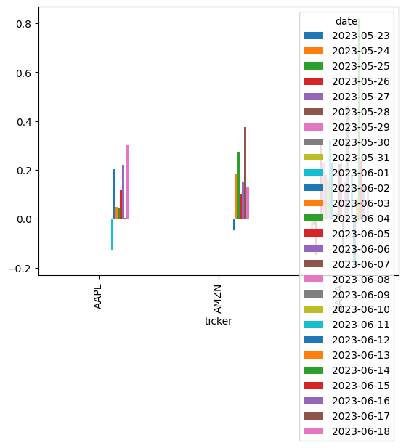

This chart displays bars representing the distribution of positive and negative sentiments in stock news. The height of the bars indicates the relative proportion of each sentiment. The positive sentiment bar shows how much proportion of the stock news has positive sentiment. The negative sentiment bar shows how much proportion of the stock news has negative sentiment.

By looking at this graph, we can visually see the comparison between positive and negative sentiments in the analyzed stock news.

# **Summary**

In this project, results are obtained from identifying positive and negative stock news using sentiment analysis with visualization. I collected stock news data from finviz.com website and applied effective data retrieval techniques. Next, I performed sentiment analysis on the news text using the NLTK library. I also used visualization using matplotlib library to show the distribution of positive and negative sentiments in stock news. The results of this project show that sentiment analysis can be used as an effective tool to identify sentiment in stock news. We can distinguish between positive and negative stock news based on the sentiment score obtained. In addition, the visualization of graphs and charts helps to better visualize and understand the distribution of sentiment in stock news.

With this project, investors, stocks enthusiast and market participants can utilize sentiment analysis to gain additional insights into stock movements and market sentiment. By knowing the positive and negative sentiments contained in stock news, they can make more informed and effective investment decisions.

However, keep in mind that sentiment analysis has limitations and is not completely accurate. Context factors, such as market changes and other news, can also affect overall market sentiment. Therefore, this study provides an important initial foundation for sentiment analysis in the context of stock news, but further research is needed to improve the precision and accuracy of the analysis results.

##### **References**

1. Mitchell, R. (2019). Web Scraping with Python: A Comprehensive Guide. Packt Publishing.
2. Official Beautiful Soup Documentation: https://www.crummy.com/software/BeautifulSoup/bs4/doc/
3. Pang, B., & Lee, L. (2008). Opinion Mining and Sentiment Analysis. Foundations and Trends® in Information Retrieval, 2(1-2), 1-135. DOI: 10.1561/1500000011